**JSS MAHAVIDYAPEETHA**

**JSS SCIENCE AND TECHNOLOGY UNIVERSITY**

**SRI JAYACHAMARAJENDRA COLLEGE OF ENGINEERING**

**MYSORE-570006**

A Synopsis on

**“HOME AUTOMATION”**

Submitted for the fulfillment of the CIE for the course

**Design and Implementation lab (EC67L)**

Submitted by

|  |  |
| --- | --- |
| **NAME** | **USN** |
| Harshith Gowda K R | 01JST17EC110 |
| Vinayak Y S | 01JST17EC107 |
| Pruthvi K N Aradhya | 01JST17EC111 |

# Under the guidance of

|  |  |
| --- | --- |
| **Dr. U B Mahadeva swamy** | **Prof. Megha K.M.** |
| Professor, | Assistant Professor, |
| Department of E&C, | Department of E&C, |
| JSS Science and Technology | JSS Science and Technology |
| University, Mysore | University, Mysore |
| **INDEX:-** |  |

|  |  |  |
| --- | --- | --- |
| Sl No | Contents | Page Numbers |
|  | Abstract | **3** |
|  | Introduction |  |
|  | Motivation |  |
|  | Objective |  |
|  | Literature Survey |  |
|  | Methodology |  |
|  | Block Diagram |  |
|  | Working |  |
|  | Software and Hardware Requirements |  |
|  | Software Requirements |  |
|  | Hardware Requirements |  |
|  | Future Scope |  |
|  | References |  |

**ABSTRACT**

# HOME AUTOMATION

# INTRODUCTION

In the computer age of the 21st century, more and more tasks are becoming automated. Automation can make things easier, safer, and often more cost efficient. What was once the stuff of world’s fairs and science fiction is today a reality, so learn about the benefits and capabilities of applying today’s technology to your home.

Smart Home Systems are the subset of everyday computing which includes smart technology for providing comfort, health, safety, security and energy reduction. When this application is controlled by machine intelligence to provide circumstance-aware settings, services and facilitate remote control it significantly improves user comfort. Further addition of automated appliance control and accessibility services can improve the quality of life as well.Internet of things that contain multiple sensors can detect temperature, light, sound, distance, air pressure, motion which act as different points of data sources. Since there is a huge amount of data involved Machine learning can be applied to the existing Home automation systems to make it perform exceptionally well based off the users emotions. Android software development is the process by which applications are created for devices running the Android operating system.In this project we try to combine all the above technologies to work in single atmosphere to get more benefites out of the system.

Home Automation enables you to use your home's lighting, heating and appliances more conveniently and efficiently. And, at the same time giving you greater levels of comfort and security. Home Automation is anything that gives you automatic control of things around the home, turning it from "dumb" to smart.

Even the most modest smart home represents the cutting edge, fully connected experience,there are numerous reasons to start converting home onto your smart home.

# LITERATURE SURVEY

|  |  |  |
| --- | --- | --- |
| **Title of the paper** | **Publishing year** | **Methodology** |
| [1] IoT Based Real-Time Control and Monitoring System for Food Grain Procurement and Storage | 2020 | Design and develop an IoT enabled food grain monitoring  system that are stored in closed storage yards and report the humidity, temperature and the  presence of gases inside the yard, there by preventive measures can be carried out in an appropriate manner. |
| [2] IoT Based Grain Storage Monitoring with Android Application | 2021 | IoT based monitoring system that allows a handheld terminal to communicate and provides a forum for daily updates on the situation of stored wheat grains. Through using this monitoring device, the proposed system would serve as an assisting government side, which can easily take care of its stored grains. |
| [3] Prediction and Monitoring of stored food grains health using IoT Enable Nodes | 2020 | Monitoring the food grain’s health using conventional methods, which detect insects at a very later stage due to which food grain get spoil. The major parameter that should be observed for maintaining the quality of grains are temperature, relative humidity, and carbon dioxide concentration. |
| [4] Theoretical Basis and System Establishment of China Food Safety Intelligent Super | 2019 | Food safety supervision system through IOT technology, achieve smart and intelligent supervision, and solve the problems of food safety supervision. In addition, based on analyzing the disadvantages of existing applications, the paper also proposes improvement measures, establishes an IoT-based framework of food safety supervision system, and proposes the relevant recommendations to guarantee the successful implementation of the system. |
| [5] RFID Enabled Smart Data Analysis in a Smart Warehouse  Monitoring System using IoT | 2020 | Machines in an industry can be connected to a single Circuitry and can be monitored through IoT with the help of the sensors and the RFID. This system mainly comprises of sensors, Arduino Uno, RFID Tag, RFID Reader, Wi-Fi Module, Buzzer and the IoT.In this method, the sensors sense parameters and deliver the desired signals to the Arduino Uno along with the accessed RFID Tag for the values read by the sensors, transmits those signals to the RFID Reader. |
| [6] IoT Monitoring System for Grain Storage | 2020 | IoT devices are used to gather this information in order to better understand what is required for the crops grown  on the farm and to increase productivity of the farm. |
| [7] Sensor based warehouse monitoring and control | 2018 | Designed and prototyped a warehouse monitoring system for maintenance of the warehouse. The system was tested using a Zigbee transceiver (ETRX357) and Buzzer circuit. |

# MOTIVATION

# To make a better living experience for challenged and disabled people, and an idea of being independent and confident on themselves.

# Home automation is converting your existing home into a complete smart home…the home automation system provides complete security to your home and also contributes to the concept of green building

# Sci-Fi moves which make life look more sophisticated and smart.

IoT is fast becoming an indispensable part of our lives – often without us realizing it. Its applications extend to all areas of computing and internet connectivity, from the most commonly used devices (such as desktops, laptops, smartphones and tablets) to the most complex devices. Homeowners can benefit from “Smart Homes”, while people with disabilities can use assistive technology such as voice control features to provide comfort and safety. The potential extends to almost any industry and facet of life, The data captured on these devices through sensors reveals interesting patterns that have immense value in business and marketing.

As businesses realize the huge value of the insights drawn from the IoT-device data, enormous opportunities for IoT specialists arise. The technology promises to enhance data resources, improve efficiencies, and increase productivity for organizations globally. If there’s ever been a fantastic time to leap into this path-breaking technology, it’s now.

# PROBLEM STATEMENT

Usually conventional Hall switches are located in different. corners of a house and, thus necessitate the need of manual operations like pressing to turn the loads on or off. It becomes very difficult for the elderly or physically handicapped people to operate them.To reduce mechanical work and human resources in larger systems.

The field of Automation has well advanced in Industries, as majority of automobile industry plants as well as bottling plants have Automated assembly lines. But automation has not yet penetrated in the homes especially in India. If automation was to be used in homes than everyday life would be get eased. Simple example of use of automation in home can be seen in the transfer of water from the under-ground water tank to the over-head water tank, by sensing the level of water in both the tanks. This process eases the every time effort the user has to put in for filling the tank and also helps in saving water. Also people are getting more acquainted daily with the use of Smartphone and tablets which are capable of doing much of PC’s work handy. So we have decided to make a low cost Embedded System in which the smart phones can be used to help automate entire home. In this system the user will have remote access and control over all the subsystems present in the house.

Electronic based track circuits in place of machinal relays or switches.More customized android application other than some paid open source.

# OBJECTIVES

Home Automation can be used in:

Saving resources like water, electricity and fuel by making optimum use of them using various feedback systems. Reducing effort and time. In improving the security of home by 24*7 surveillance. Can be of immense help to physically handicapped person

* As much as auto controlled home **appliances.**
* **Handy android app and voice commanding.**
* **Highly accurate image processing techniques for face detection.**
* Larger data base.
* Accuracy in real time dimness control and temperature indication.
* Compatibility of both manual and auto control.
* Provide knowledge about recent innovations in agriculture and production.
* Provide updates regarding new schemes and financial supports.

## METHODOLOGY AND BLOCK DIAGRAM

Providing data base and training for face detection.

Rigging up of track circuit and controlling appliances with it.

Data collection and correlation of sensors.

Actuation accordingly.

App layout and User Interface.

Voice control all Above.

Integration of all above.

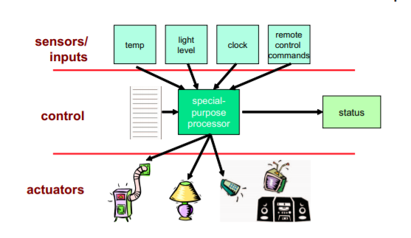

**PROPOSED BLOCK DIAGRAM**

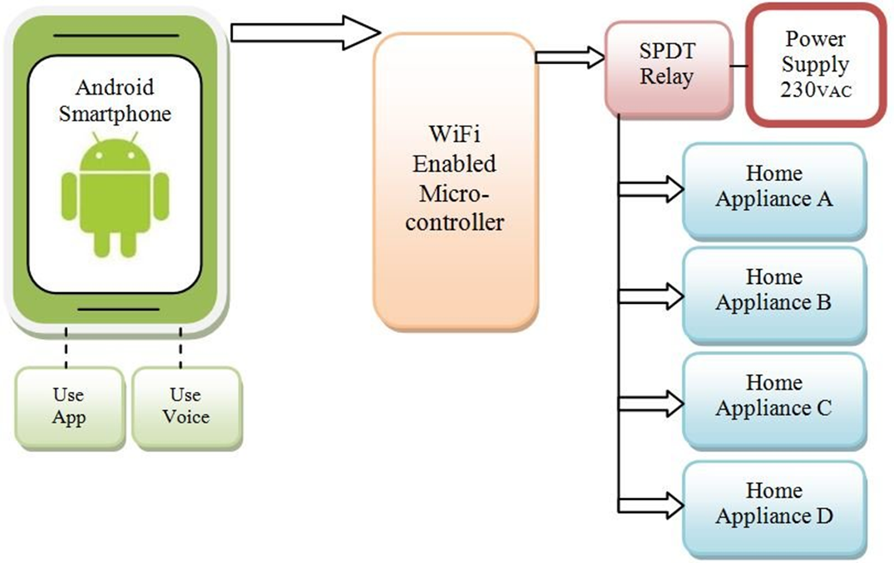

**WORKING**

# CODE

import cv2  
import numpy as np  
from os import listdir  
from os.path import isfile,join  
import serial  
import time  
import pyttsx3  
q=1  
x=0  
c=0  
m=0  
d=0  
while q<=2:  
 data_path = 'C:/Users/user/Desktop/python/image/'  
 onlyfiles = [f for f in listdir(data_path) if isfile(join(data_path,f))]  
 Training_data, Lebels = [],[]  
 for i , files in enumerate(onlyfiles):  
 image_path = data_path + onlyfiles[i]  
 images = cv2.imread(image_path,cv2.IMREAD_GRAYSCALE)  
 Training_data.append(np.asarray(images, dtype = np.uint8))   
 Lebels.append(i)  
  
 Lebels = np.asarray(Lebels, dtype = np.int32)  
 model = cv2.face.LBPHFaceRecognizer_create()  
 model.train(np.asarray(Training_data),np.asarray(Lebels))  
 print("training complete")  
 q+=1  
face_classifier = cv2.CascadeClassifier('C:/Users/user/AppData/Local/Programs/Python/Python38\Lib/site-packages/cv2/data/haarcascade_frontalface_default.xml')  
  
  
def speak(audio):  
 engine.say(audio)  
 engine.runAndWait()  
engine = pyttsx3.init('sapi5')  
voices=engine.getProperty('voices')  
engine.setProperty("voice",voices[0].id)  
engine.setProperty("rate",140)  
engine.setProperty("volume",1000)  
  
  
  
  
  
  
def face_detector(img, size= 0.5):  
 gray = cv2.cvtColor(img,cv2.COLOR_BGR2GRAY)  
 faces = face_classifier.detectMultiScale(gray,1.3,5)  
  
 if faces is():  
 return img,[]  
 for(x,y,w,h) in faces:  
 cv2.rectangle(img, (x,y),(x+w,y+h),(0,255,255),2)  
 roi = img[y:y+h, x:x+w]  
 roi = cv2.resize(roi,(200,200))  
   
 return img,roi  
  
cap = cv2.VideoCapture(0)  
while True:  
 ret, frame = cap.read()  
  
 image, face = face_detector(frame)  
  
 try:  
 face = cv2.cvtColor(face,cv2.COLOR_BGR2GRAY)  
 result= model.predict(face)  
 if result[1]<500:  
   
 confidence = int((1-(result[1])/300)*100)  
 display_string = str(confidence)  
 cv2.putText(image, display_string,(100,120),cv2.FONT_HERSHEY_SCRIPT_COMPLEX,1,(0,255,0))  
  
 if confidence>=83:  
 cv2.putText(image,"unlocked",(250,450),cv2.FONT_HERSHEY_SCRIPT_COMPLEX,1,(0,255,255))  
 cv2.imshow('face',image)  
 x+=1  
 else:  
 cv2.putText(image,"locked",(250,450),cv2.FONT_HERSHEY_SCRIPT_COMPLEX,1,(0,255,255))  
 cv2.imshow('face',image)  
 c+=1  
 except:  
 cv2.putText(image,"Face not found",(250,450),cv2.FONT_HERSHEY_SCRIPT_COMPLEX,1,(0,255,255))  
 cv2.imshow('face',image)  
 d+=1  
 pass  
   
 if cv2.waitKey(1)==13 or x==10 or c==30 or d==20:  
 break  
cap.release()  
cv2.destroyAllWindows()  
if x>=5:  
 m=1  
 ard = serial.Serial('com5' ,9600)  
 time.sleep(2)  
 var = 'a'  
 c=var.encode()  
 speak("Face recognition complete..it is matching with database...welcome..sir..Door is openning for 5 seconds")  
 ard.write(c)  
 time.sleep(4)  
elif c==30:  
 speak("face is not matching..please try again")  
elif d==20:  
 speak("face is not found please try again ")  
if m==1:   
 speak("door is closing")

# PROJECT OUTCOMES

* Face recognition of given data base (family members).
* Door unlock mechanism after recognition.
* Room temperature measuring.
* Fan speed control.

# SOFTWARE REQUIREMENTS

**Software** :-

- Coding platform (Arduino and Prthivi software).

- voice control (Google assistant).

Arduino programming board: C language

**IDE**

The Arduino integrated development environment (IDE) is a cross-platform application (for Windows, macOS, Linux) that is written in the programming language Java. It originated from the IDE for the languages Processing and Wiring. It includes a code editor with features such as text cutting and pasting, searching and replacing text, automatic indenting, brace matching, and syntax highlighting, and provides simple one-click mechanisms to compile and upload programs to an Arduino board. It also contains a message area, a text console, a toolbar with buttons for common functions and a hierarchy of operation menus. The source code for the IDE is released under the GNU General Public License, version 2. The Arduino IDE supports the languages C and C++ using special rules of code structuring. The Arduino IDE supplies a software library from the Wiring project, which provides many common input and output procedures. User-written code only requires two basic functions, for starting the sketch and the main program loop, that are compiled and linked with a program stub main() into an executable cyclic executive program with the GNU toolchain, also included with the IDE distribution. The Arduino IDE employs the program avrdude to convert the executable code into a text file in hexadecimal encoding that is loaded into the Arduino board by a loader program in the board's firmware.

**RELAY:**

A relay is an electrically operated switch. Many relays use an electromagnet to mechanically operate a switch, but other operating principles are also used, such as solid-state relays. Relays are used where it is necessary to control a circuit by a separate low-power signal, or where several circuits must be controlled by one signal. The first relays were used in long distance telegraph circuits as amplifiers: they repeated the signal coming in from one circuit and re-transmitted it on another circuit. Relays were used extensively in telephone exchanges and early computers to perform logical operations.

The Arduino Relay module allows a wide range of microcontroller such as Arduino, AVR ,PIC, ARM with digital outputs to control larger loads and devices like AC or DC Motors, electromagnets, solenoids, and incandescent light bulbs. This module is designed to be integrated with 2 relays that it is capable of control 2 relays.The relay shield use one QIANJI JQC-3F high-quality relay with rated load 7A/240VAC,10A/125VAC,10A/28VDC.The relay output state is individually indicated by a light-emitting diode.

**Hardware** :-

- Microcontroller (Arduino /NodeMCU).

- Sensors, servo & Camera module.

- Track circuit/relay

**REFERENCES**

* Smart Home Automation Using Machine Learning Algorithm

-IEEE 2020.

* Home Automation Using Internet of Things.

by- Shopan Dey, Ayon Roy & Sandip Das.

* Home Automation System

by- Javier Castro and James Psota

MORE PAPERS WITH LINK..